Bitcoin Accumulation Beyond Uniform DCA
A Data-Driven Framework Using On-Chain and Prediction Market Signals
Team 08: Chenhao Qian, Shuang Gong

Contents
Summary 3
1. Introduction 4
2. Data Sources 4
3. Exploratory Analysis and Signal Development 4
4. Model Design 6
5. Results 7
Conclusion 8
Summary
Dollar-cost averaging (DCA) remains one of the most common ways to accumulate Bitcoin because it is simple, disciplined, and easy to stick with over time. At the same time, it rests on a strong assumption: that every day is equally worth buying. In this project, we asked whether that assumption could be improved upon without turning the problem into short-term price prediction.
Rather than trying to forecast where Bitcoin would go next, we focused on a more practical question. If the goal is long-term accumulation, are there market conditions that tend to be better entry environments than others? To explore that question, we combined Bitcoin on-chain data with prediction market data from Polymarket and tested whether a rule-based, interpretable framework could allocate capital more effectively than uniform DCA.
The strongest result from our analysis is that valuation still matters most. Lower MVRV regimes were consistently associated with better accumulation outcomes. At the same time, the best entry windows were not usually the most extreme panic periods. They appeared more often in what we describe as an active churn regime: Bitcoin looked relatively undervalued, exchange netflows showed moderate outflows, and on-chain participation remained healthy. This combination turned out to be more useful than looking at valuation in isolation.
Polymarket data also added value, but in a more indirect way. Event activity worked better as a risk filter than as a return predictor. When macro event flow was active, forward drawdown risk tended to be lower; when event flow was quiet, downside risk was often higher. Whale directional flow and a probability-volatility risk index offered some additional context, although both were weaker than the core on-chain signals.
We incorporated these findings into a dynamic accumulation framework and tested it in rolling one-year windows beginning on 2018-01-01. Across 2,557 windows, the final model outperformed uniform DCA 67.77% of the time and achieved a Final Model Score of 65.38%. On average, it improved sats accumulated per dollar by 21.26%. Overall, our results suggest that Bitcoin accumulation can be improved without relying on black-box forecasting. Better timing in this setting comes less from perfect prediction and more from better filtering of market conditions.

1. Introduction
DCA is popular for a good reason. Most investors do not have a reliable way to call tops and bottoms, and trying to time every move usually leads to inconsistent decisions. A fixed buy schedule solves that problem by replacing judgment with discipline.
Still, as we worked through this practicum, we kept returning to one basic question: are all days really equally attractive for long-term Bitcoin buying? Bitcoin moves through changing valuation regimes, changing participation regimes, and changing macro risk environments. If those conditions are meaningfully different from one period to the next, then buying the same amount every day may not be the best use of capital.
That led us to frame the project around a practical accumulation problem rather than a trading problem. We were not trying to predict tomorrow's return. Instead, we wanted to know whether we could identify periods that were more favorable for long-term accumulation and scale buying intensity up or down accordingly.
Our project had three main goals. First, we wanted to test whether on-chain data could identify systematically better buying windows. Second, we wanted to see whether prediction market activity contained useful information about risk, sentiment, or speculative conviction. Third, we wanted to combine those signals into an interpretable framework and compare it directly against standard DCA.

2. Data Sources
The project uses two main data sources. The first is daily Bitcoin on-chain data from CoinMetrics, covering 2018-01-01 through 2025-12-31. This dataset includes price, market capitalization, MVRV, exchange inflows and outflows, active address count, transaction activity, and other network-level indicators. From those raw variables, we also built derived features such as 30-day forward returns, forward drawdown, rolling volatility, distance from the 200-day moving average, and drawdown from the all-time high.
The second source is Polymarket data covering markets from 2023 through 2026. We worked with market metadata, event-level activity, odds history, and trade-level records. From these data, we created daily features such as active event count, total active volume, a whale directional flow measure based on larger trades, and a Polymarket risk index based on rolling probability volatility.
These two sources played different roles in the project. The on-chain data described Bitcoin's own valuation and participation dynamics. The Polymarket data gave us a way to capture information flow, speculative positioning, and macro event context. In the final framework, the on-chain signals serve as the main anchor, while the prediction market signals act as a layer of additional context.

3. Exploratory Analysis and Signal Development
To make our findings more coherent, we organized this section around four signals that emerged most clearly from the exploratory analysis. Rather than listing every pattern we observed, we focused on the signals that helped answer our main question: whether Bitcoin accumulation can be improved by identifying more favorable market environments instead of treating every day as equally attractive. These four signals are on-chain value and active churn, macro event anchoring, whale smart money, and the risk index regime filter.

3.1 Signal 1: On-Chain Value and Active Churn
The strongest signal in our analysis came from on-chain valuation, especially when combined with participation. Across the full sample, lower MVRV regimes were generally associated with better forward accumulation conditions, confirming that valuation remains the most reliable starting point for long-term Bitcoin buying. This was the clearest pattern we found, and it became the foundation for the rest of the framework.
At the same time, our results suggested that valuation alone was not enough. The best accumulation windows did not usually appear during the most extreme panic or disorder. Instead, they tended to appear when Bitcoin looked undervalued, exchange flows showed moderate outflows, and network participation remained relatively healthy. We refer to this combination as active churn. What makes this signal useful is that it captures a more constructive kind of weakness: price is attractive, but the network still looks active rather than broken.
This turned out to be one of the most important insights in the project. It suggests that the best buying environments are not necessarily the most chaotic ones, but those in which undervaluation is still supported by continued participation. Figure 1 shows this pattern, where the strongest forward outcomes appeared when value and participation conditions aligned.
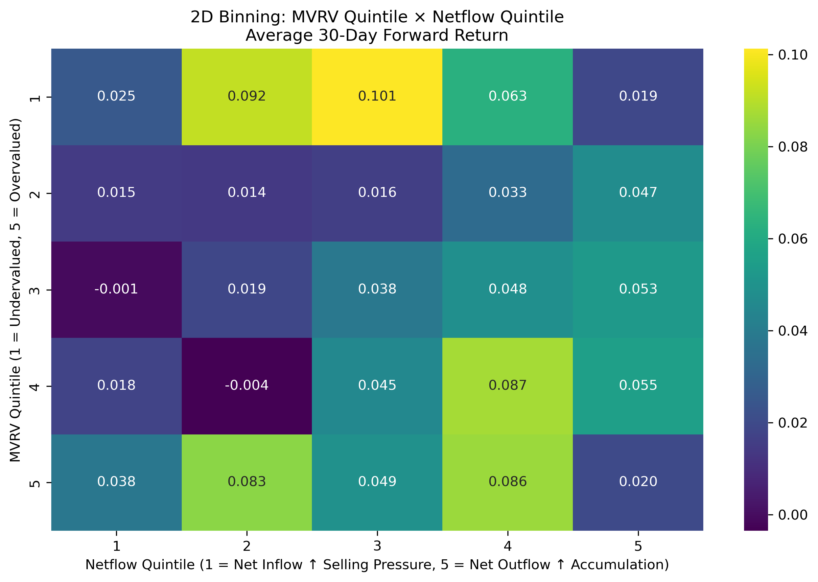
Figure 1. The strongest forward outcomes appeared in an active churn regime, where undervaluation coincided with moderate exchange outflows and healthy on-chain participation.

3.2 Signal 2: Macro Event Anchor
The second signal came from prediction-market event activity. When we first incorporated Polymarket data, one of our main questions was whether event activity might help predict Bitcoin returns more directly. What we found was more subtle. Event activity did not consistently behave like a strong return predictor, but it did appear useful as a macro anchor for risk conditions.
Periods with more active prediction-market events tended to coincide with lower downside risk in the following period, while quieter periods often looked more vulnerable. We interpret this as a difference between markets with an active information flow and markets with relatively little anchoring information. When event activity is high, market participants are responding to visible macro narratives and repricing expectations in a more structured environment. When it is low, the market may be more exposed to unanchored sentiment and adverse moves.
For that reason, we treated macro event activity less as an alpha signal and more as a contextual guide. It helped us distinguish between environments in which undervaluation could be acted on more confidently and those in which caution was more appropriate. Figure 2 illustrates this relationship by showing that event activity was more informative for downside-risk filtering than for predicting return magnitude directly.
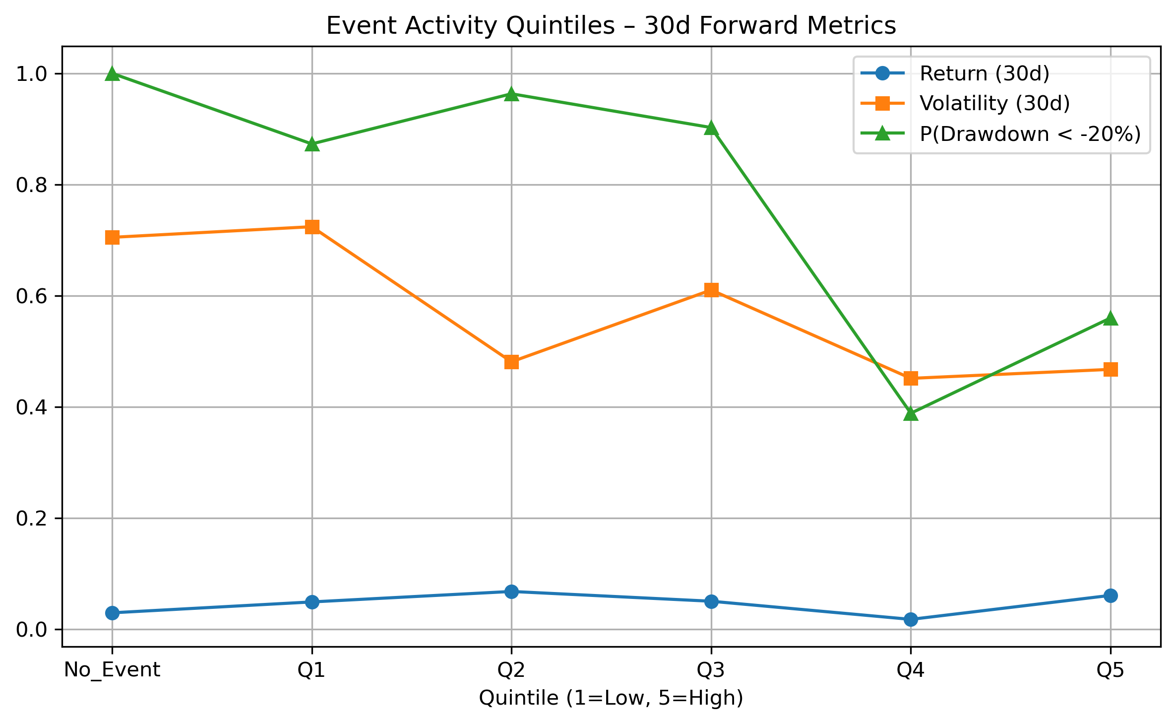
Figure 2. Prediction-market event activity was more informative for filtering downside risk than for predicting return magnitude directly.

3.3 Signal 3: Whale Smart Money
The third signal came from larger trades in the prediction-market data. We used this to construct a whale directional flow measure, based on the idea that larger participants may at times reveal directional conviction earlier than broader market behavior does. In our analysis, more bullish large-bet net flow was generally associated with better forward accumulation conditions.
This result was interesting because it pointed to the possibility that speculative conviction from larger participants may contain useful information, especially when combined with the stronger on-chain signals. At the same time, this was not one of the most mature parts of the project. The available trade-level history was much shorter than the history for the on-chain data, so the evidence here should be treated more cautiously.
For that reason, we did not treat whale flow as a primary anchor on its own. Instead, we viewed it as a lighter overlay that could strengthen or weaken conviction around the main regime signals. In other words, it was useful, but not strong enough to carry the framework by itself.
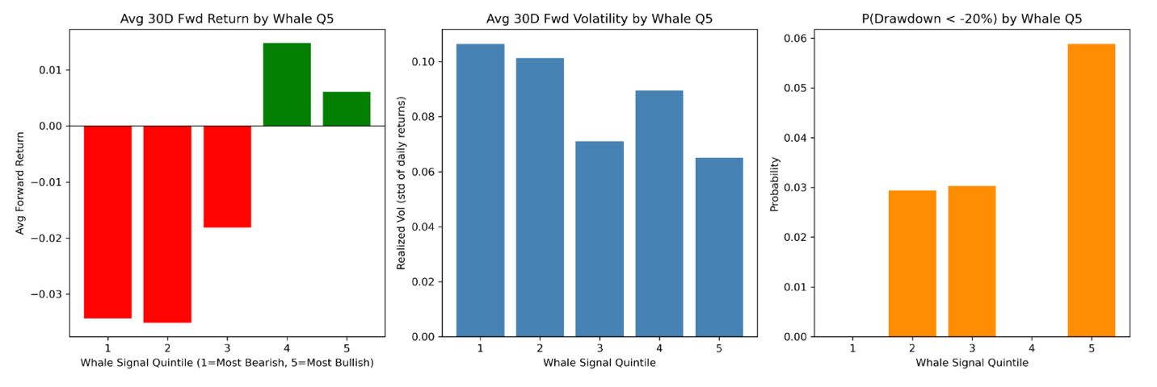
Figure 3. More bullish whale directional flow was generally associated with better forward accumulation conditions, although the evidence was more limited than for the core on-chain signals.

3.4 Signal 4: Risk Index Regime Filter
The fourth signal was the prediction-market risk index, constructed from cross-market probability volatility. Conceptually, we treated this as a way to capture how unstable or uncertain the broader event environment appeared at a given time. Unlike the value signal or active churn, this was not meant to identify cheapness directly. Instead, it helped describe the type of regime in which the market was operating.
Empirically, the risk index behaved more like a regime filter than a directional signal. Higher readings tended to appear in more uncertain environments and were often associated with elevated price regimes, while lower readings were more common in quieter or earlier-cycle conditions. This did not make the index especially useful as a stand-alone predictor, but it did make it valuable as context.
We therefore treated the risk index as a way to scale conviction rather than generate it. If the valuation and participation signals already looked favorable, the risk index helped determine whether those signals should be acted on more aggressively or more conservatively. In that sense, it served as a final layer of regime awareness within the broader framework.
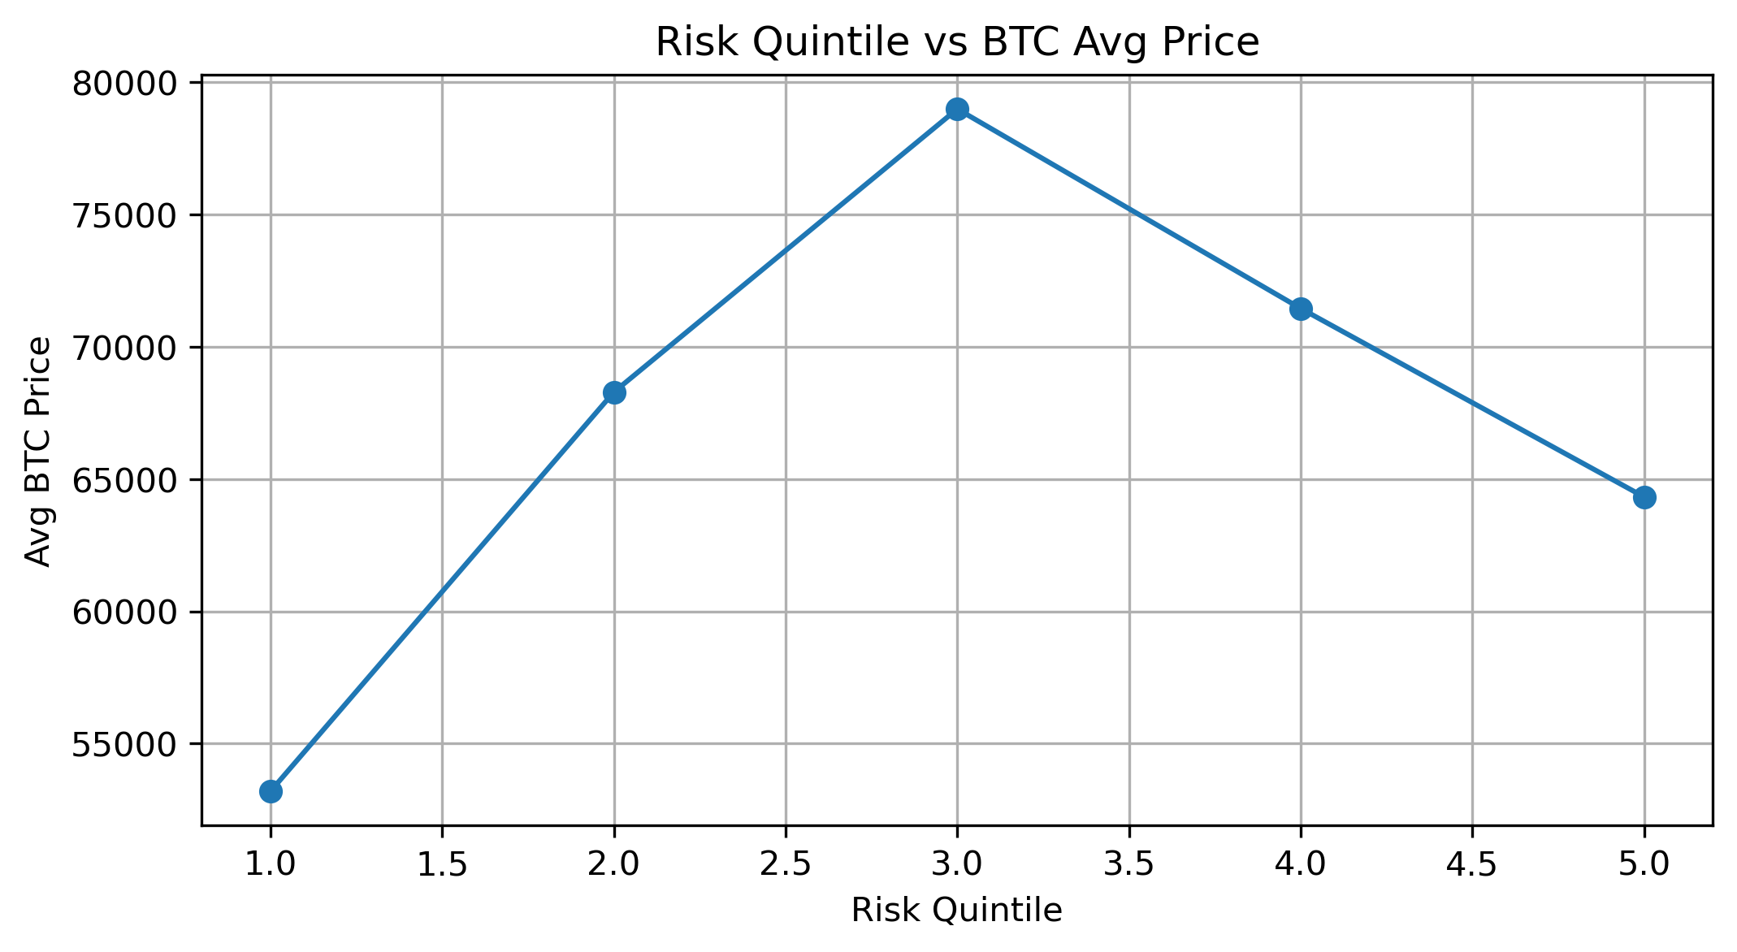
Figure 4. The prediction-market risk index functioned mainly as a regime filter, helping distinguish between different macro uncertainty environments.
Taken together, these four signals gave us a more structured way to think about Bitcoin accumulation. On-chain value and active churn provided the strongest foundation, macro event activity added a risk-sensitive information anchor, whale flow contributed a lighter conviction overlay, and the risk index helped filter broader market regimes. In the next section, we explain how these signals were translated into the final allocation framework.
4. Model Design
We chose a transparent, rule-based framework rather than a black-box prediction model. Since the goal was long-term accumulation, we wanted the model to be easy to interpret and easy to explain: why should the framework buy more on one day and less on another?
Signal | Weight | Direction
MVRV value signal | 45% | Low z-score = undervalued = buy more
200-day MA deviation | 12% | Price below MA = buy more
Active churn composite | 21% | Moderate outflow + active addresses = buy more
Whale directional flow | 10% | Bullish big-bet net flow = buy more

These weighted signals form the model's base score. On top of that, we apply lighter modifiers tied to event activity, risk conditions, and volatility to determine whether the framework should act more aggressively or more conservatively in a given environment. All inputs are lagged to avoid look-ahead bias. The final output is a daily allocation multiplier relative to standard DCA.
5. Results
We evaluated the framework using rolling one-year backtests beginning on 2018-01-01. For each window, we compared the model against uniform DCA using sats-per-dollar (SPD), which directly measures how efficiently invested capital is converted into Bitcoin.
 | New Model | DCA with 200MA | Example 1 model
Final Model Score | 65.38% | 51.74% | 59.54%
Win Rate | 67.77% | 61.05% | 60.31%
Exponential Decay Percentile | 62.98% | 42.43% | 58.78%
Mean Excess Percentile | 7.80% | 1.04% | 5.70%
Median Excess Percentile | 7.42% | 1.23% | 6.43%
Mean Relative Improvement | 21.26% | 2.61% | 16.82%
Median Relative Improvement | 19.87% | 3.37% | 17.99%
Mean Ratio (Dynamic/Uniform) | 1.21 | 1.03 | 1.17
Total Windows | 2,557 | 2,557 | 2,557
Wins | 1,733 | 1,561 | 1,542
Losses | 824 | 996 | 1015

Across 2,557 rolling windows, the final model outperformed standard DCA in 67.77% of cases. The average improvement in sats accumulated per dollar was 21.26%, with a median improvement of 19.87%. These gains were not isolated to a single metric. The model also improved timing quality percentile measures and performed better than both a simpler DCA-plus-200-day-moving-average baseline and an earlier Polymarket-enhanced version of the framework.
What matters most to us is that the model's edge appears consistent with the logic of the signal design. The gains do not seem to come from a single narrow condition. Instead, they reflect a more general improvement in how capital is allocated across favorable and unfavorable environments.

Conclusion
Looking back, the main takeaway from this project is fairly straightforward. Long-term Bitcoin accumulation does not necessarily need better short-term prediction. It needs a better way to distinguish between stronger and weaker buying environments.
The strongest foundation in our framework is still valuation. MVRV remained the single most reliable anchor throughout the analysis. At the same time, the most useful new finding for us was the active churn regime. The best accumulation windows were often not the moments of maximum panic, but the periods when Bitcoin looked undervalued and on-chain participation still appeared healthy. That result made the project feel more practical, because it offered a more concrete answer to when buying more may actually make sense.
Polymarket data added another layer to that picture. It did not consistently tell us how large future returns would be, but it helped us characterize the surrounding risk environment. Event activity, in particular, was more useful as a filter for downside conditions than as a direct return signal. Whale directional flow and the risk index also looked promising, but given the shorter sample, we think it is more honest to treat them as supportive signals rather than fully established pillars.
There are also clear limitations to the work. The final model is rule-based, which keeps it interpretable but leaves room for more systematic optimization. Some of the most interesting Polymarket features have limited history, especially whale flow. In addition, the project focuses on accumulation timing rather than the broader questions of transaction costs, tax effects, or portfolio construction.
If we were extending this project further, the next steps would be to optimize signal weights more formally, test longer and richer prediction market histories, and explore whether slightly more flexible nonlinear methods could improve regime detection without making the framework too opaque.
Even with those limitations, we think the project reached a useful conclusion. DCA remains a strong baseline, but treating every day as equally attractive leaves information on the table. A regime-aware accumulation framework can preserve the discipline of DCA while making capital deployment more selective. In that sense, the project did not try to replace DCA so much as refine it.
If we had to summarize the report in one sentence, it would be this: better Bitcoin accumulation comes less from perfect prediction and more from smarter filtering.

